a) Inventory items are displayed in the inventory:

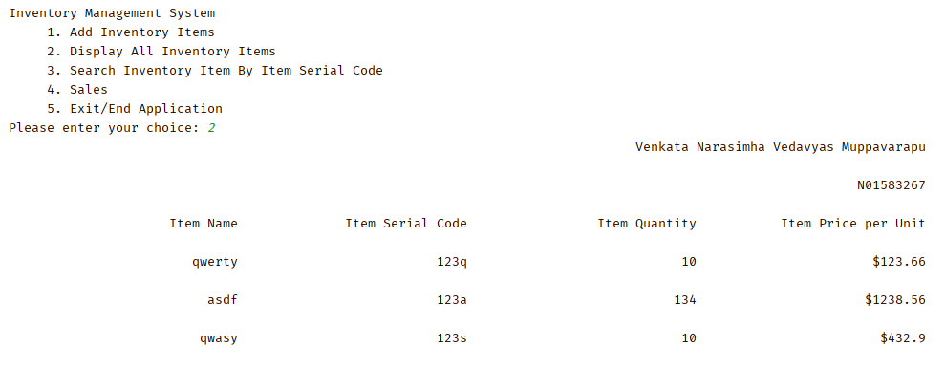

b) If there was NO item in the inventory (warehouse does not have any items) then message to that effect is displayed because there cannot be any sales if there are no items in the inventory.

c) If customer tries to buy an item that does not exist in the inventory, following message is displayed:

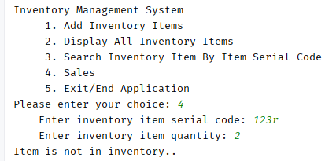

CONTINUE TO NEXT PAGE

d)If customer tries to buy items from the inventory but the number of items in the inventory are less than the quantity that the customer wants to purchase, then following message is displayed:

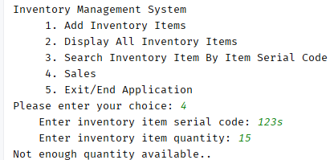

e) As the customer purchases items from the inventory – if items were available with sufficient quantity, then following table (Sales Invoice) is displayed (and same information is also emailed to the customer as invoice):

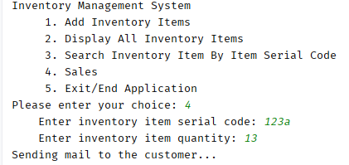

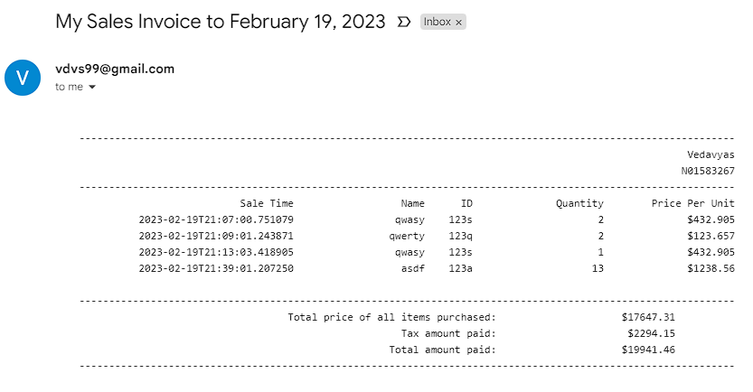

f) If the customer buys the existing total inventory, then the inventory will be removed and will be added to sales.



